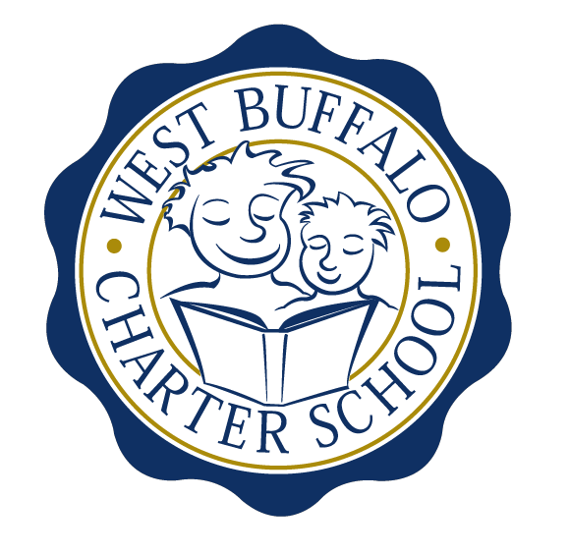

West Buffalo Charter School

Board of Trustees Meeting
March 27, 2017
2:30 PM
D’Youville College, Buffalo, New York

Board Members
Present: Arup Sen, Michelle Stevens, James Deuschle, Richard Baer, James Sampson, Lee Pearce, Amy Friedman, Lynn Shea, Joanne Haefner
Also Present: Liz Sterns, Andrea Todoro
Quorum Present: Yes

Call to Order
Dr. Sen called the meeting to order at 2:36PM. Quorum present.

Proof of Public Notice of Meeting
Media and public announcement was sent on Monday, March 20, 2017 to print, radio, and TV outlets announcing this open meeting. A posting was also sent to Erie County Hall, Buffalo City Hall and Buffalo City Court. In addition, it was publicly displayed at 50 East North Street and posted on the WBCS website. The Board of Trustees was duly notified of this meeting well within the timeline of our bylaws.

Monthly Meeting

Review of the February 28, 2017 Meeting Minutes
Minutes of the February 28, 2017 Board of Trustees meeting were presented for approval.

Upon motion duly made by Mr. Baer and seconded by Mrs. Stevens, the minutes of the February, 2017 board meeting were approved as presented. All in favor. Non-opposed.

Financial Report
Mrs. Sterns presented the financial reports for the period ending February 28, 2017 (a copy is attached hereto and made a part hereof).

- Mrs. Sterns presented an update on the Phase IV expansion.
- Discussion regarding the Phase V finance summary. Questions were answered by Mrs. Sterns and Mr. Deuschle.

Upon motion duly made by Mr. Sampson and seconded by Mrs. Friedman the board approved Mrs. Sterns to act on behalf of the board in banking negotiations pertaining to the Phase V expansion. All in favor. Non-opposed.

Upon motion duly made by Mr. Baer and seconded by Ms. Haefner, the February 28, 2017 financial statements were approved as presented. All in favor. Non-opposed.

School Leader Report
- Mrs. Todoro presented the School Leader report.
- Discussion regarding New York State testing accommodations requested and Buffalo Public School’s CSE’s response.

New Business

- The board agreed that at least one retreat should be planned for the immediate future. Mrs. Friedman will be reaching out to one local facilitator.

Adjournment
Being that there is no further business to discuss, a motion to dismiss was made by Mrs. Pearce and seconded by Mrs. Friedman. The meeting was adjourned 3:57 PM.

Respectfully submitted,
Leslie Bunis Ohl

The next WBCS board meeting will take place on Monday, April 24th, 2:30PM at D’Youville College, Bauer Family Academic Center, Room 105.

